

American International University-Bangladesh (AIUB)
Department of Computer Science and Engineering
Faculty of Science &Technology (FST)
Summer 2024
CSC 00191- Object Oriented Analysis And Design (OOAD)
Section: Q
Project Title: FACEBOOK MANAGEMENT SYSTEM

Submitted by:
Arpita Islam

Submitted to:
MD. ANWARUL KABIR
Associate Professor
Department of Computer Science

1. Project Overview: The Facebook Management System is designed to provide comprehensive tools and features to manage and enhance the experience of users on the Facebook platform. This system primarily offers the following functionalities:
1. Profile Management: Users can set up and manage their profiles.
2. Content Sharing: Users can post updates, share content, and interact with other users' posts.
3. Friend Connections: Users can send and receive friend requests to connect with others.
4. Group Management: Users can create, join, and manage groups.
5. Event Management: Users can create and participate in events.
6. Messaging: Users can send and receive messages.
7. Engagement: Users can like, comment, and share posts and pages.
8. Privacy Control: Users can manage privacy settings and control the visibility of their content.
9. Notifications: Users can receive notifications about various activities and updates.
To efficiently provide these functionalities, the Facebook Management System is structured around the following microservices:
1. User Profile Service: Core service to manage user profiles, including profile creation, updates, and retrieval.
2.Post Service: Handles the creation, management, and retrieval of user posts.
3. Friend Service: Manages friend requests, connections, and friend lists.
4. Group Service: Manages group creation, membership, and group activities.
5. Event Service: Handles event creation, invitations, and participation tracking.
6. Messaging Service: Manages real-time messaging between users.
7. Notification Service: Manages the delivery of notifications to users about various activities and updates.
8. Privacy Service: Manages user privacy settings and controls the visibility of user content.
9. Reaction Service: Handles likes, comments, and shares on posts and pages.
This system design document will detail how each microservice operates and integrates within the Facebook Management System. Each microservice section will include: - Diagrams illustrating incoming and outgoing services. - API architecture and definitions. - Sample API requests for reference. - Database design and schema examples where applicable.

2. Justification:
The Facebook Management System is a significant advancement in social media management, tailored to meet the dynamic needs of today's digital landscape. By offering robust profile management, content sharing, and engagement tools, it enhances user experience and fosters deeper connections among users. Real-time messaging and notifications ensure that users stay informed and engaged, while privacy controls provide users with the power to manage their online presence securely. The system's comprehensive admin and moderation features ensure a safe and well-regulated platform, where community guidelines are consistently enforced, and user concerns are promptly addressed. This results in a trustworthy environment where users feel comfortable sharing and interacting. Furthermore, the Facebook Management System supports the creation and participation in groups and events, which strengthens community building and user engagement. By providing admins with detailed analytics and reporting tools, the platform enables data-driven decisions that enhance user satisfaction and system performance.
4. Overall Use Case of the project:
We have four main actors in our system: User: The primary actor who interacts with most features. Users can manage their profiles, join and manage groups, create and attend events, share content, connect with friends, send and receive messages, control their privacy settings, and receive notifications. Admin: Responsible for the overall management and moderation of the platform. Admins handle high-level administrative tasks and ensure that community standards are maintained. Moderator: Focuses on monitoring content to ensure it complies with community guidelines. Moderators handle reports, manage inappropriate content, and assist in maintaining the system's integrity. Developer: Ensures the smooth operation and updating of the system. Developers are responsible for system maintenance, implementing updates, and fixing bugs to enhance the platform's functionality. Key Use Cases of the Facebook Management System: - Profile Management: Users can create, edit, and manage their personal profiles. - Group Management: Users can create and manage groups for various interests and activities. - Event Management: Users can create and manage events, as well as RSVP to events. - Content Sharing: Users can share photos, videos, and other types of content with their friends and groups. - Friend Connections: Users can send and accept friend requests to connect with other users. - Messaging: Users can send and receive private messages. - Privacy Control: Users can manage their privacy settings to control who sees their information and posts. - Notifications: Users receive notifications about friend requests, messages, event invites, and other activities. - Management: Admins perform high-level management tasks, including user and content moderation. - Moderation: Admins and moderators work together to ensure community guidelines are followed. - Content Monitoring: Moderators monitor user content to ensure it adheres to community standards. - System Maintenance: Developers perform regular system maintenance to ensure smooth operation. - System Updates: Developers implement system updates and improvements. This diagram captures the essential interactions between users, admins, moderators, and developers, illustrating how they engage with different aspects of the Facebook Management System to ensure a seamless and safe user experience.

5. Class diagram of the project:

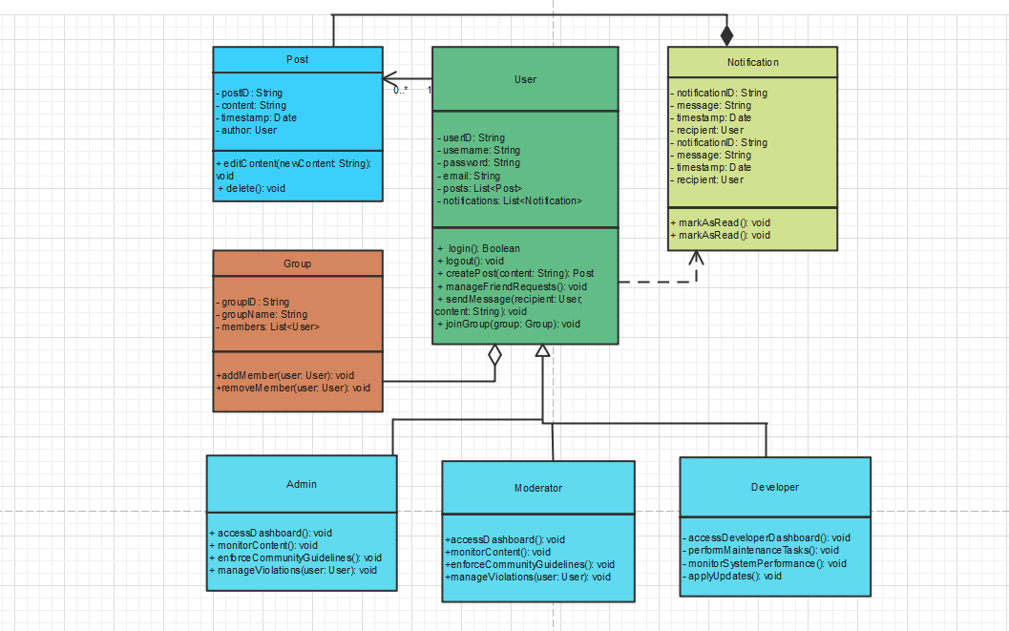

6. Activity Diagram of the project:
In the Facebook Management System, a user starts by logging into the platform using their credentials. If the login is successful, they are directed to the home page, where they can view recent posts, notifications, and access various features like creating posts, managing friend requests, sending messages, join groups. If the log in is not successful, then the log in will be failed. Admins and moderators can log in to their respective dashboards after verifying by the dashboard. Then they can monitor content, enforce community guidelines and manage users who violate rules. Meanwhile, developers access the system verifying by the developer dashboard and then they can perform maintenance tasks, monitor system performance and apply updates. Once any actor (user, admin, moderator, or developer) completes their tasks, they log out of the system, concluding their session.

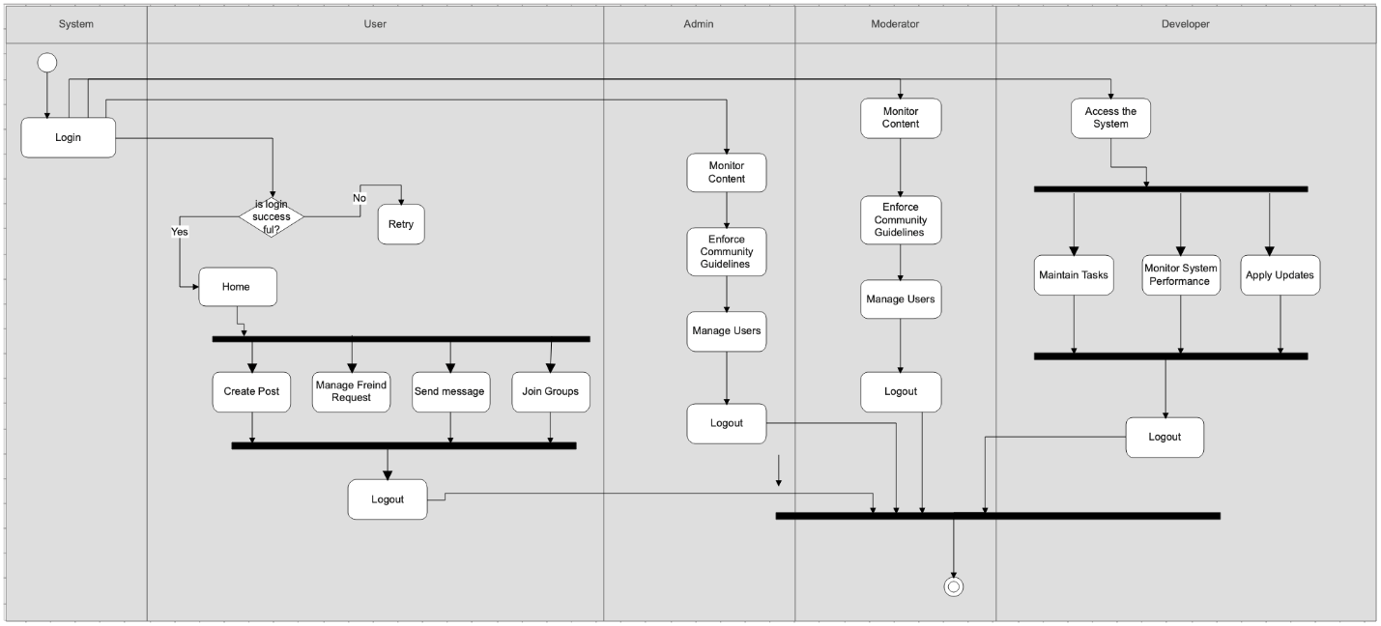

7. Sequence Diagram of the project
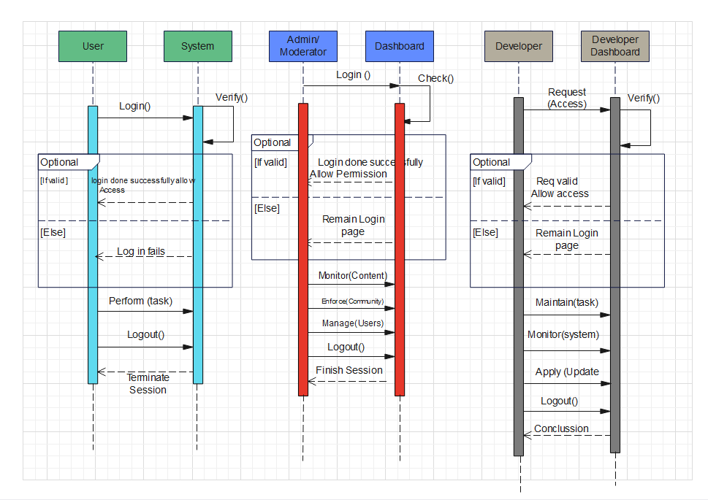

8. Statechart Diagram:

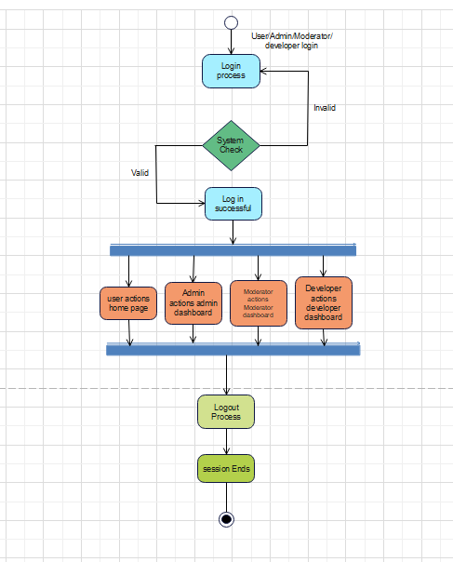

9. Conclusion:
The Facebook Management System is designed to facilitate various types of user interactions, from standard social media activities to administrative and developer tasks, with distinct workflows and functionalities tailored to each role. Regular users can log in to the system, where they can view posts, send messages, manage friend requests, and join groups. This system incorporates a seamless login process that either directs users to their home page or, in the case of a failed login, provides feedback for corrective action.
For higher-level users like admins, moderators, and developers, the system includes an additional layer of verification through their respective dashboards. This ensures that only authorized personnel can access sensitive administrative features. Admins and moderators oversee content and enforce community guidelines, ensuring that user-generated content adheres to platform standards. Developers, on the other hand, focus on maintaining system performance, conducting updates, and ensuring platform stability through the developer dashboard.
The system’s structure is modular, with clear relationships and dependencies between its various components. Features such as posts, notifications, and group memberships are well-managed, showcasing a one-to-many and many-to-one relationship model that allows scalability. Additionally, the system’s workflow— from login to logout—ensures a user-friendly experience while maintaining strict access control and functionality division among different roles.
Overall, the design integrates robust content management, system maintenance, and secure user interactions, making it a comprehensive solution for running a large scale social media platform. It not only supports everyday social media use but also incorporates the necessary tools for managing users, content, and system health, ensuring a well-regulated and reliable experience for all types of users.

